Differential pressure gauges:
DELTA-line, now even more robust

Klingenberg, February 2014.
A new generation of the WIKA “DELTA-line” product family for differential pressure measurement is now available. A newly designed measuring cell makes the four instruments in the range even more robust and thus they will last even longer.

The measuring instruments, which also feature a shatter-proof window, are corrosion-resistant and have the best possible degree of protection against external mechanical influences. As a result of their unchanged dimensions and connections, customers can replace old with new without any problem. A new dial design highlights the visible difference to the previous models.

The DELTA-plus (pressure gauge), DELTA-comb (gauge with one or two micro switches) and DELTA-trans (transmitter) instruments not only have a mechanical differential pressure indication but also have an integrated working pressure indication. The family is completed by the DELTA-switch (differential pressure switch with one or two micro switches).

The DELTA products work with a measuring range from 0 ... 250 mbar. They are generally used where there are high requirements in terms of one-sided overpressure and static pressure, for example, for the monitoring and control of filters, compressors and pumps.

Number of characters:1309
Key word: DELTA-line

WIKA company photograph:
WIKA product family “DELTA-line”

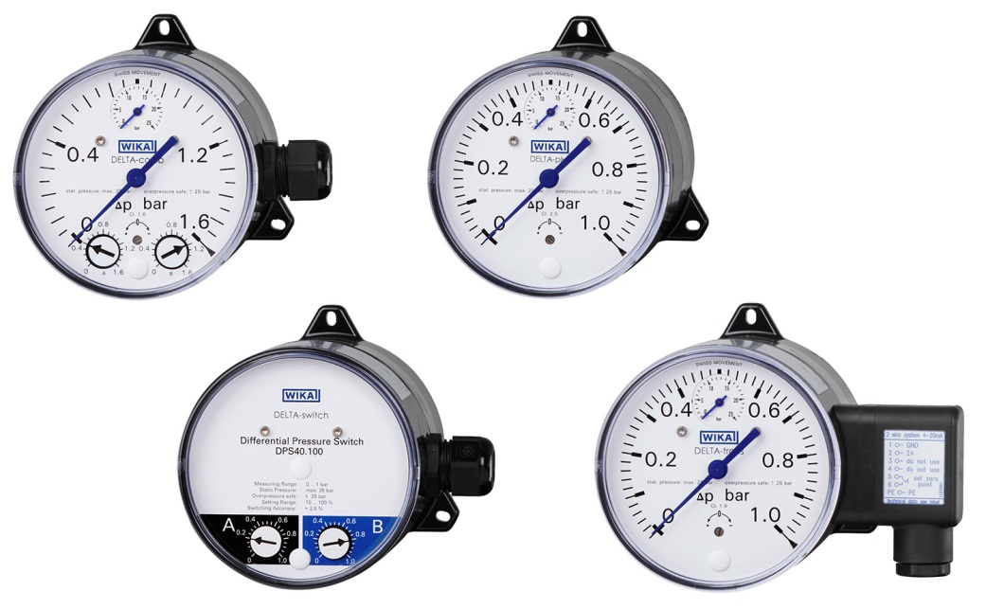

Edited by:
WIKA Instruments Ltd.
3103 Parsons Road
Edmonton, AB T6N 1C8 Canada
Tel. (+1) 780 463-7035
Fax (+1) 780 462-0017
E-mail marketing.ca@wika.com
www.wika.ca

WIKA press release 02/2014

