Resistance thermometers and thermocouples
calibrated at the same time

Klingenberg, April 2015.
The new CTR3000 multi-functional precision thermometer from WIKA offers a unique “two-in-one” solution: It can be used to calibrate resistance thermometers and also thermocouples.

With up to 44 channels for different sensor types and therefore a wide temperature range, as well as with an accuracy of up to 0.005 K, the CTR3000 is designed for high operational flexibility. A new, intuitive user interface makes all information visible at a glance via eight menu items. Automatic scanning of the channels, the graphical representation with simultaneous calibration, the export of the logged data to Excel and software updates via a USB stick support its time-efficient handling.

The new CTR3000 has been developed as a joint-venture project by Automatic Systems Laboratories (ASL) and WIKA and will be sold under the WIKA label. The British company ASL is a market leader in precision instruments for temperature measurement. Since 2013 it has been part of the WIKA Group.

Number of characters: 971
Key word: CTR3000

WIKA company photograph:
Precision thermometer CTR3000

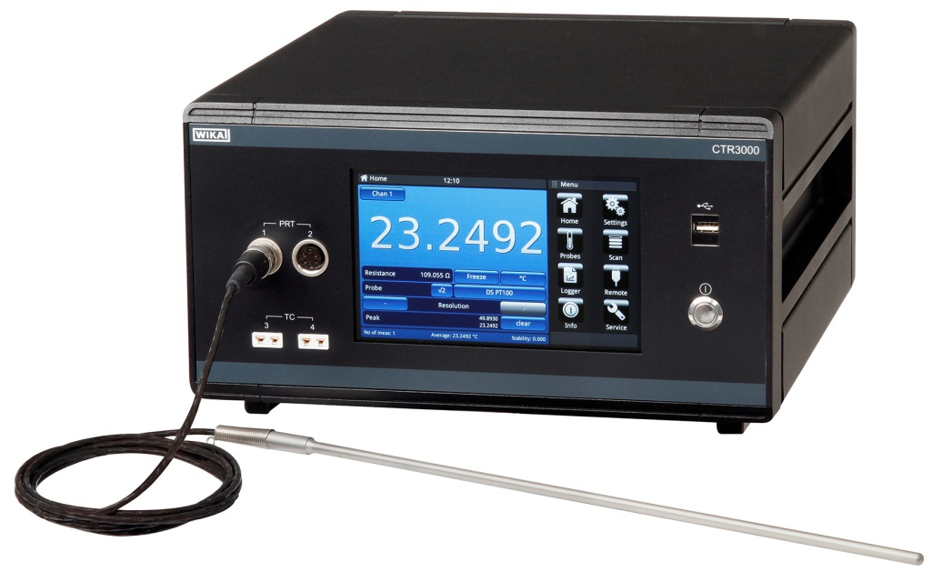

Edited by:
WIKA Instruments Ltd.
3103 Parsons Road
Edmonton, AB
T6N 1C8
Canada
Tel. (+1) 780 463-7035
Fax (+1) 780 462-0017
E-mail marketing.ca@wika.com
www.wika.ca

WIKA press release 08/2016

