Hygienic diaphragm pressure gauge:
IP68 for cleaning with highly aggressive media

Klingenberg, June 2021. The model PG43SA-S diaphragm pressure gauge for sanitary applications can now be delivered with an optional vent valve. With the valve closed (ingress protection IP68), the inside of the instrument is permanently protected against penetration by extremely aggressive substances such as those used for external cleaning in certain pharmaceutical processes.

While the instrument is actually performing its duty, pressure measurement (gauge pressure), the valve must be open. This also applies to sterilisation in an autoclave, to prevent internal pressure having negative effects.

The hygienically designed vent valve is easily accessible on top of the case. It is adjusted, without tools, using a wing nut; a locking ring prevents it from unscrewing. Open and closed positions, as well as the direction of rotation, are clearly marked.

Number of characters: 831
Keyword: PG43SA-S with vent valve

WIKA company photograph:
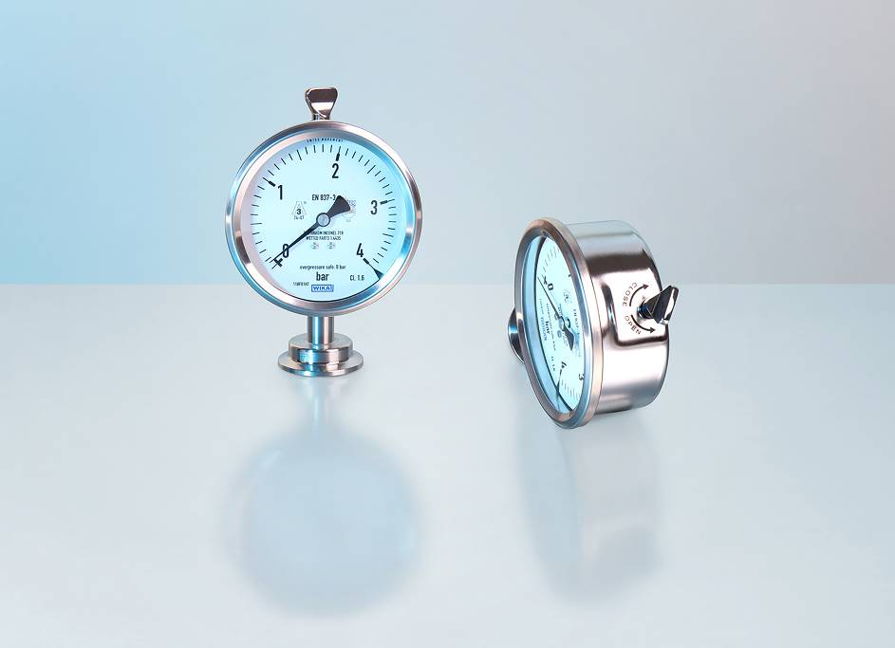
Model: PG43SA-S with vent valve

Edited by:
WIKA Instruments Ltd.
3103 Parsons Road NW
Edmonton, AB T6N 1C8 Canada
Tel. (+1) 780 463-7035
Fax (+1) 780 462-0017
E-mail: marketing.ca@wika.com

www.wika.ca

WIKA press release

