New temperature sensors
in miniature design

Klingenberg, January 2014.
They are so small that you hardly notice them: With their minimal design, the new temperature sensors from WIKA fit in even the tightest of spaces. The model TF40 was developed specifically for use in ventilation ducts; the model TF41 for the measurement of outside temperatures.

The measuring elements of both sensors are inserted into a UV-resistant plastic housing that measures just 44(l) x 32(w) x 30(h) mm. The new instrument, classified with IP 65 ingress protection, can be supplied with a choice of Pt1000, Pt100, NTC or a customer-specific solution. Thus they are compatible with all the common control systems.

The model TF40 is tailored to the needs of air-conditioning and ventilation technology. Optional equipment includes a plastic mounting flange and a thermowell. The model TF41 is primarily suitable for the fields of renewable energies, HVAC and refrigeration technology. For this model, there is an additional, clip-on protective module to prevent erroneous measurements as a result of too strong incident sunlight in outside applications.

Number of characters: 1127
Key words: TF40/TF41

WIKA company photograph:
WIKA temperature sensors TF40 and TF41

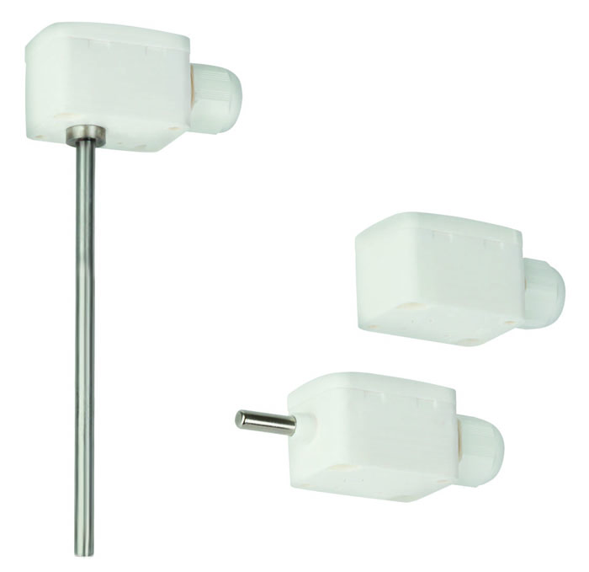

Edited by:
WIKA Instruments Ltd.
3103 Parsons Road
Edmonton, AB T6N 1C8 Canada
Tel. (+1) 780 463-7035
Fax (+1) 780 462-0017
E-mail marketing.ca@wika.com
www.wika.ca

WIKA press release 01/2014

