Robust submersible pressure sensors
with many options

Klingenberg, January 2017.
WIKA has extended its portfolio by two high-performance submersible pressure sensors with a slimline design. As a result of the many options in a single instrument, they offer an exceptionally attractive price-performance ratio.

The model LW-1 is suitable for level monitoring of water and wastewater. The model LF-1 features long-lasting resistance within all common oils and fuels. Both submersible pressure sensors are, with their slimline case diameter of 22 mm (< 1 inch), ideal for use within pipes. Thanks to a newly developed sealing concept, special cable and further options, such as Ex and overvoltage protection during lightning strikes, the instruments work reliably even under harsh conditions.

The new submersible pressure sensors are available with a variety of output signals. The low-power signals enable battery operation from 3.6 V, and its life is increased enormously through the fast response times and a low current consumption. The monitoring of the medium temperature is possible via an optional analogue output. The parameterisation of unit and error signal, and also the scaling of the measuring range, is carried out via HART® communication.

General information on hydrostatic level measurement can be found by the user at www.wika.com/hydrostatic-level.

Number of characters: 1282
Key word: LF-1/LW-1

WIKA company photograph:
Model LF-1 submersible pressure sensor and model LW-1 submersible pressure sensor

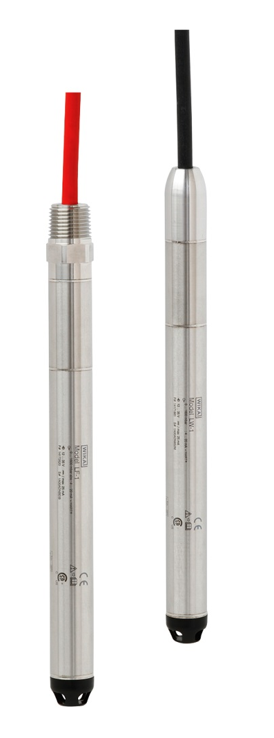

Edited by:
WIKA Instruments Ltd.
3103 Parsons Road
Edmonton, AB T6N 1C8
Canada
Tel. (+1) 780 463-7035
Fax (+1) 780 462-0017
E-mail marketing.ca@wika.com
www.wika.ca

WIKA press release 01/2017

