WIKA acquires Scandura

Klingenberg, January 2012.
With the acquisition of Scandura, WIKA has taken a further step to strengthen its leading role in the field of calibration technology.

Scandura, founded in Italy in the 1950s, from the start established itself internationally as a manufacturer of special calibration applications.

The portable calibrators, in particular, meet the highest demands and safety standards, and they offer reliable measuring equipment (for example with ATEX certificates and for critical applications in the process industry). The complete calibration systems enjoy a special reputation as well. Calibration software rounds out the portfolio.

Scandura will be integrated into the calibration technology division of the WIKA Group.

Number of characters: 753
Key words: Acquisition of Scandura

WIKA company photograph:
Portable calibrator "Pascal ET/IS"

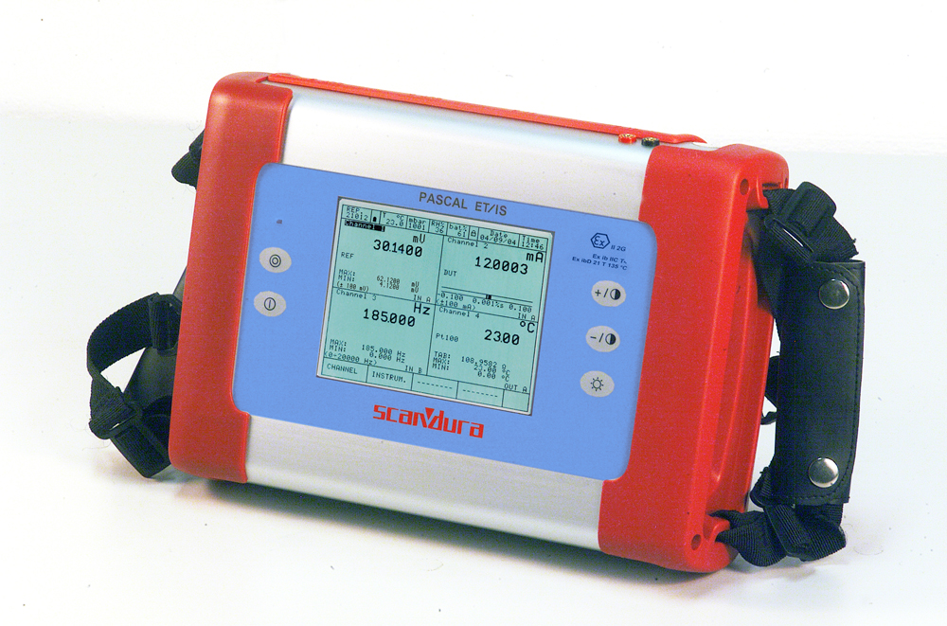

Edited by:
WIKA Instruments Canada Ltd.
3103 Parsons Road
Edmonton, AB T6N 1C8
Canada
Tel. (+1) 780 463-7035
Fax (+1) 780 462-0017
E-mail marketing@wika.ca
www.wika.ca

WIKA press release 02/2012

