**WIKA acquires ASL and Wilkins standard resistors**

## **press release**

**Edmonton, AB Canada February 2014**

**With the acquisition of ASL, WIKA has taken a further step to strengthen its leading role in the market of calibration technology.**

ASL manufactures and supplies precision temperature metrology and calibration equipment worldwide, areas where WIKA already has an established presence. The ASL line of AC resistance thermometry bridges are used as primary standards in many national laboratories and offer an uncertainty second to none.

**As part of the acquisition, the Wilkins standard resistors line was also acquired.**

**The design of the Wilkins standard resistors is a result of several years of development. It has evolved over time as a result of many tests on stability and temperature coefficient using both AC and DC.** The Wilkins design has been adopted by national and major industrial laboratories as their primary standard.

WIKA believes the ASL products and the Wilkins resistors will continue to contribute to the strengthening of WIKA’s leading role in the market of calibration technology.

 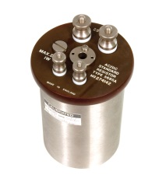

**AC Resistance Thermometry Bridge Wilkins Resistor**

**Edited by:**

WIKA Instruments Canada Ltd.

Lloyd Clarke

Marketing Manager

2679 Bristol Circle, Unit 1

Oakville, ON L6H 6Z8

Tel: 905.337.1611

Fax: 905.337.2716

E-mail: [l.clarke@wika.ca](mailto:l.clarke@wika.ca)

[www.wika.ca](http://www.wika.ca/)