New flange monoblock
with shut-off valve
Klingenberg, January 2021. WIKA's new monoblock with flange connection has been designed for applications in the process industry. The compact design integrates a shut-off valve to separate the process from the instrument side.

The one-piece construction and the double sealing (metal and plastic), tested in accordance with BS6755 / ISO 5208 leakage rate A, give the compact instrument the greatest possible safety. Its high-quality manufacture ensures smooth handling, even at high process pressures. The model IBF1 can be fitted with either a ball valve or needle valve.

The new instrumentation valve complements the existing monoblock portfolio which includes the models IBF2 (block & bleed) and IBF3 (double block & bleed). On request, WIKA supplies a customer-specific assembly of measuring instrument and monoblock (“instrument hook-up”), ready for operation and leak-tested. All IBF models can also be fitted on level indicators and differential pressure measuring instruments for level measurement.

Number of characters: 980
Key word: IBF1

WIKA company photograph:
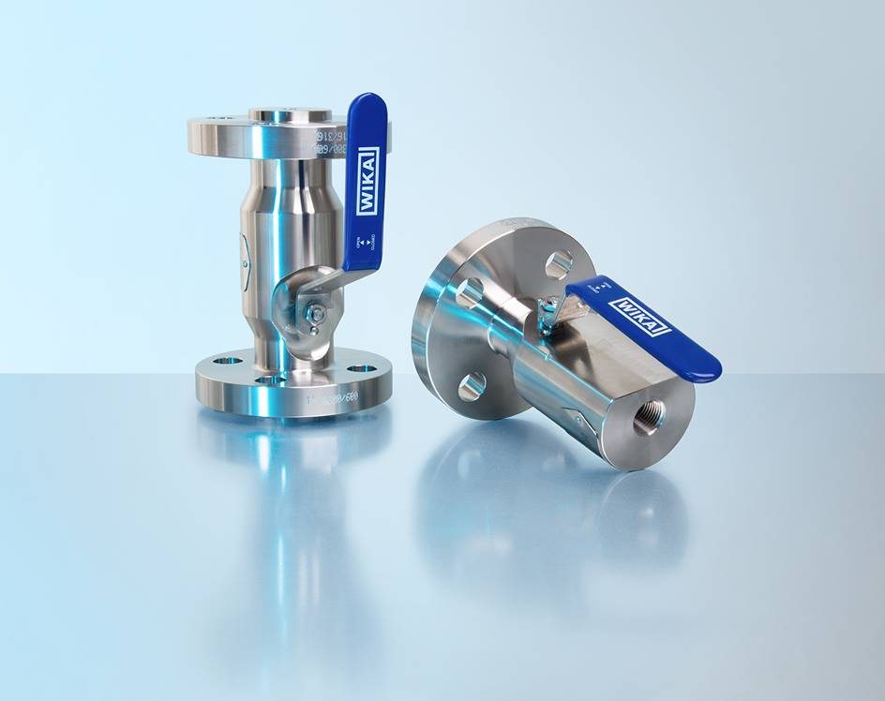
Model: IBF1

Edited by:
WIKA Instruments Ltd.
3103 Parsons Road NW
Edmonton, AB T6N 1C8 Canada
Tel. (+1) 780 463-7035
Fax (+1) 780 462-0017
E-mail: marketing.ca@wika.com
www.wika.ca

WIKA press release

