New pressure switch with wide adjustable
switch differential and high repeatability
Klingenberg, March 2019.
WIKA has tailored its new mechanical pressure switch to a wide range of requirements in the process industry. The model PSM-700 offers a switch differential adjustable over a wide range, very high repeatability and a rugged case.

The PSM-700 has a UL-listed micro switch that switches at electrical powers up to AC 250 V/10 A. With a switch point repeatability of
≤ 0.5 %, itoffers long-lasting high reliability. The high adjustability of the switch differential – up to 60 % of the setting range – enables flexible on/off switching. The instrument can be delivered with setting ranges from -1 … 1.5 bar to 7 … 35 bar.

A robust aluminium case and wetted parts made of corrosion-resistant 316L stainless steel also enable the new pressure switch to be used under harsh conditions. A dual-entry option is possible for the electrical connection (top and side) meaning the instrument can be mounted in the optimal orientation.

Number of characters: 923
Key word: PSM-700

WIKA company photograph:
New pressure switch withwide adjustable
switch differential and high repeatability

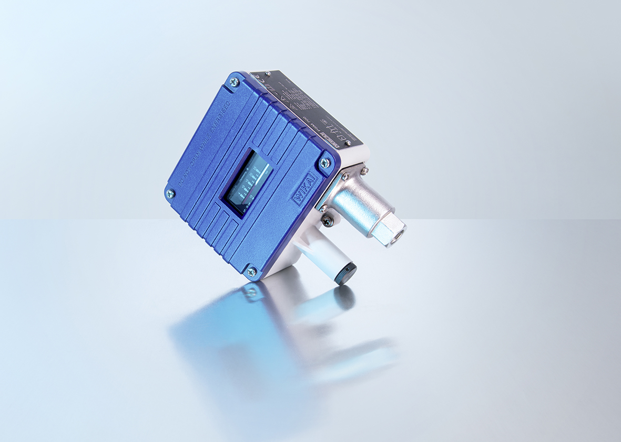

Edited by:
WIKA Instruments Canada Ltd.
3103 Parsons Road
Edmonton, AB T6N 1C8 Canada
Tel. (+1) 780 463-7035
Fax (+1) 780 462-0017
E-mail marketing.ca@wika.com
www.wika.ca

WIKA press release 03/2019

