Universal process transmitter:
Robust and highly accurate

Klingenberg, April 2014.
With the UPT-2X, WIKA has brought a new process transmitter to market. It is a highly accurate all-purpose instrument with a robust design and an on-site display.

The compact plastic housing of the UPT-2X, depending on requirements, is fitted with a measuring sensor between 0 ... 400 mbar and 0 ... 1,000 bar. The measuring ranges are freely scalable, with a maximum recommended turndown of 20:1. The transmitter is easy to work with. It communicates via the latest HART® standard (v7). With its adjustable display head, this instrument can suit almost any mounting situation. Thanks to its 60 mm display, the values are always easily readable from a distance.

As well as being suitable for almost any application, the UPT-2X is cost-effective. Tool-free handling saves time and the high long-term stability ensures low maintenance costs.

Number of characters: 920
Key word: UPT-2X

WIKA company photograph:
WIKA process transmitter UPT-2X

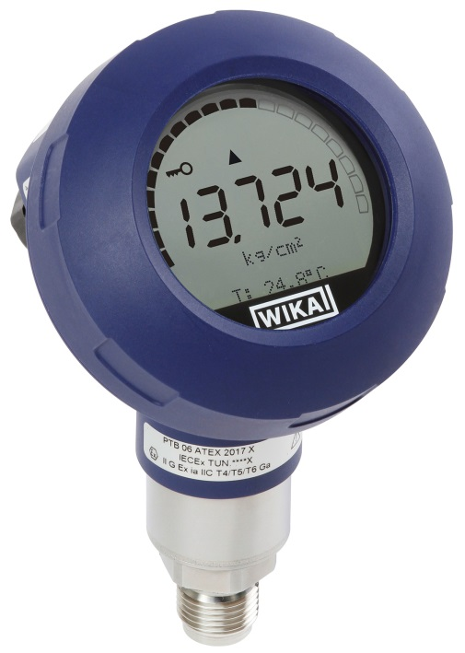

Edited by:
WIKA Instruments Ltd.
3103 Parsons Road
Edmonton, AB T6N 1C8 Canada
Tel. (+1) 780 463-7035
Fax (+1) 780 462-0017
E-mail marketing.ca@wika.com
www.wika.ca

WIKA press release 04/2014

