Brochure for machine building:
New edition with more solutions

Klingenberg, April 2018.
More application examples, more measurement technology and more services: WIKA has republished and expanded the contents of its brochure with instrumentation solutions for the machine-building industry.

This compact decision aid illustrates WIKA's spectrum of solutions for the industry for machine tools, plastics machinery and their peripheral equipment. The customer can now have a view on even more application examples. Each application is matched with relevant instrumentation from the WIKA portfolio, dependent on the need for the measured variables pressure, temperature, level, flow and force. Diaphragm seals, integrated sensors and accessories, and also customer-specific measuring assemblies expand the solution possibilities.

Furthermore, the new brochure emphasises the area of calibration technology as an accompanying offering. As well as the products, there are the services of WIKA's DAkkS-certified laboratory and the calibration van for on-site applications at the customer.

The republished decision aid is available in a printed format, or it can be downloaded as an e-book from the website www.wika.com.

Number of characters: 1123
Key words: WIKA machine-building brochure

WIKA company photograph:
Brochure for machine building:
New edition with more solutions

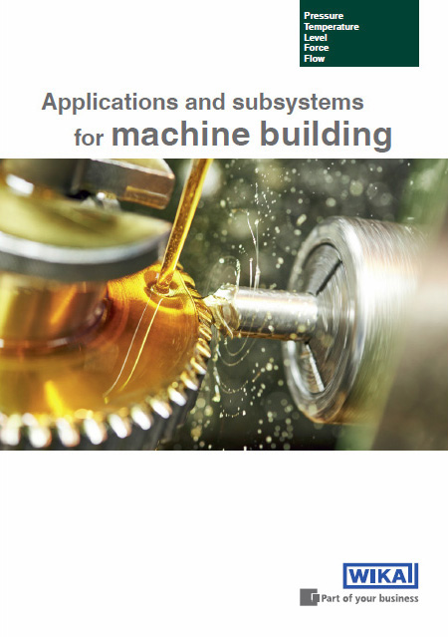

Edited by:
WIKA Instruments Canada Ltd.
3103 Parsons Road
Edmonton, AB T6N 1C8 Canada
Tel. (+1) 780 463-7035
Fax (+1) 780 462-0017
E-mail marketing@wika.ca
http://www.wika.ca/

WIKA press release 04/2018

