New electronic flow switch with display
Klingenberg, June 2021. The new model FSD-4 electronic flow switch from WIKA offers full flexibility in monitoring and controlling flow based on the velocities of liquid media.

The switch points of the model FSD-4 can be freely configured very easily via the 3-button operation directly on the instrument or optionally via IO-Link.
The model FSD-4 can output both absolute values in various units and relative flow values and display them on the digital indicator. While a flow rate value is assigned to the first switch point, it can be defined at the second switching output whether the switch should switch at a second flow value or at a specific temperature value for the medium.
In addition, the FSD-4 can be fitted with an analogue output for flow or temperature values. The wide range of parameterisation options makes the model FSD-4, with only three basic variants, an economical flow switch for a wide variety of applications and installation situations.

Number of characters: 940
Keyword: FSD-4

WIKA company photograph:
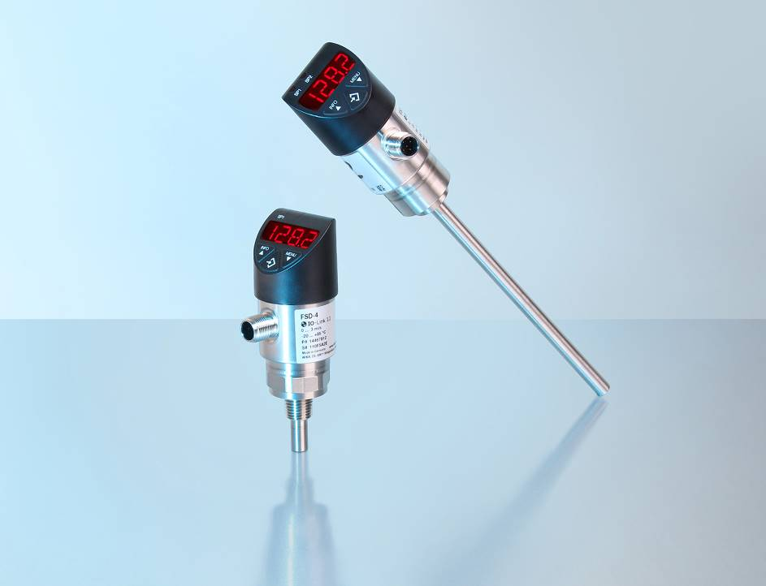
Model: FSD-4

Edited by:
WIKA Instruments Ltd.
3103 Parsons Road NW
Edmonton, AB T6N 1C8 Canada
Tel. (+1) 780 463-7035
Fax (+1) 780 462-0017
E-mail: marketing.ca@wika.com
www.wika.ca

WIKA Press release

