New temperature probe
with condensation protection

Klingenberg, February 2015
With the TF43, WIKA now offers a new temperature probe designed specifically for use in refrigeration, cooling and air-conditioning systems.

In the new insertion thermometer the measuring element and junctions to the connection cable are completely moulded with plastic. This protection prevents the formation of condensation due to frequent temperature changes in the dew point range.

The TF43 is available in several versions. It is designed for a measuring range from -50 °C … +105 °C. For measuring elements, the choice is between Pt1000 and Pt100, in addition to NTCs.

Number of characters: 572
Key words: Refrigeration temperature probe

WIKA company photographs:
Refrigeration temperature probe TF43

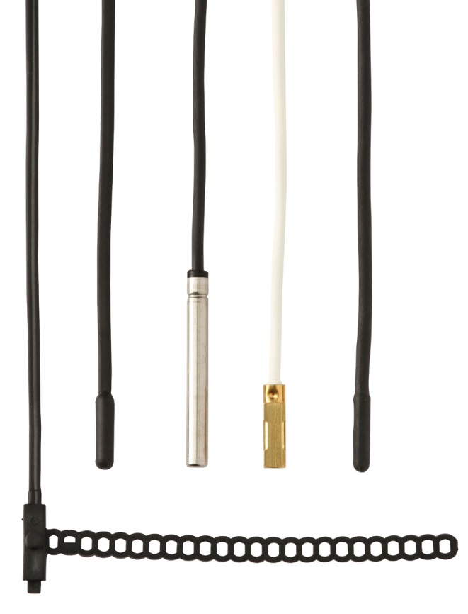

Edited by:
WIKA Instruments Ltd.
3103 Parsons Road
Edmonton, AB T6N 1C8 Canada
Tel. (+1) 780 463-7035
Fax (+1) 780 462-0017
E-mail marketing.ca@wika.com
www.wika.ca

WIKA press release 05/2015

