Digitalised safety
with new diaphragm seal system

Klingenberg, June 2021. The requirements of digitalised sterile processes are met by a new diaphragm seal system from WIKA with process transmitter, diaphragm monitoring and HART®7 protocol. The model DMSU21SA has approvals for all common hygiene standards and is available in a version with explosion protection.

The complete measuring arrangement is parameterised via a single cable outlet and HART®7. The communication protocol transmits the measured values as well as the alarm signal from the diaphragm monitoring. The patented safety function is based on a double diaphragm with evacuated intermediate space and a pressure switch. In the event of a rupture of the process-side diaphragm, the switch sends an immediate damage message while the second diaphragm continues to monitor the pressure.

The new diaphragm seal system measures pressures between -1 bar and 25 bar with an accuracy of 0.1 % of span. The model DMSU21SA is available with all sterile connections and the application-specific system fill fluids.

Number of characters: 994
Key word: DMSU21SA

WIKA company photograph:
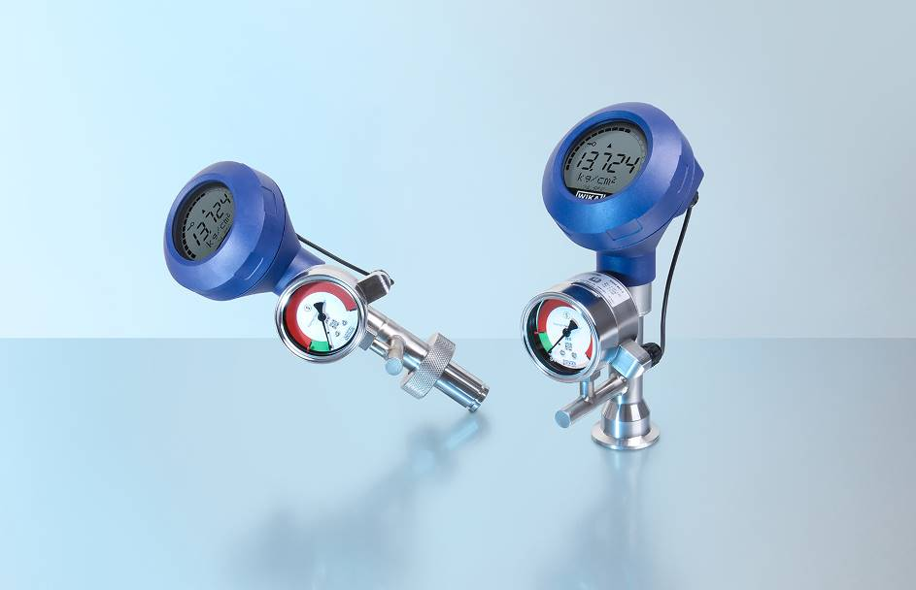
Model: DMSU21SA

Edited by:
WIKA Instruments Ltd.
3103 Parsons Road NW
Edmonton, AB T6N 1C8 Canada
Tel. (+1) 780 463-7035
Fax (+1) 780 462-0017
E-mail: marketing.ca@wika.com
www.wika.ca

WIKA press release

