Two new level transmitters:
Extremely compact and with high resolution

Klingenberg, May 2020 - With floats as small as 18 mm in diameter, the new level transmitters from WIKA also fit into space-critical locations. The model FLM-CA is designed for use in the process industry, the model FLM-CM for industrial applications.

Both compact instruments work on the magnetostrictive principle. They have a high resolution (0.1 mm) and measure with an accuracy of either ± 1.25 mm or ± 2.5 mm. The model FLM-CA is also available in a hazardous area version with ATEX approval and in a vibration-resistant version (up to 4 g).

The new level transmitters have a 4 … 20 mA output signal, the model FLM-CA can also communicate via HART6 protocol. Both level measuring instruments are available with probe lengths of up to 1 m (FLM-CM) or 3 m (FLM-CA) as well as with different temperature and pressure ranges. With an ingress protection of IP68, they are also protected against external influences.

Number of characters: 890
Key words: FLM-CA, FLM-CM

WIKA company photograph:
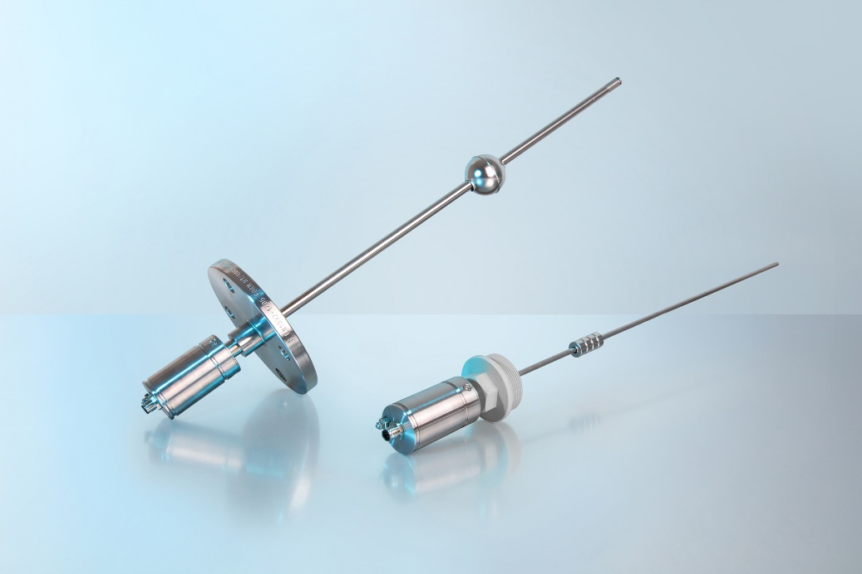
Typ: FLM-CA, FLM-CM

Edited by:
WIKA Instruments Ltd.
3103 Parsons Road NW
Edmonton, AB T6N 1C8 Canada
Tel. (+1) 780 463-7035
Fax (+1) 780 462-0017
E-mail: marketing.ca@wika.com
www.wika.ca

WIKA press release

