Through the serial number
direct to the product data

Klingenberg, May 2014.
WIKA has set up a new internet service for users of both model A-10 and model S-20 pressure transmitters: All individual product data are now available on the microsite https://portal.wika.com/serial/.

Customers can retrieve the information either by entering the serial number, or – just recently – a QR code on the included test report. This way, they get a direct access to all item details, links to the data sheet and operating instructions as well as the ability to download test reports and certificates. A successful access to the new web application also confirms that the instrument supplied is an original product from WIKA.

Number of characters: 708
Key words: Microsite serial number

WIKA company photograph:
“Intelligent” serial number for WIKA pressure transmitters

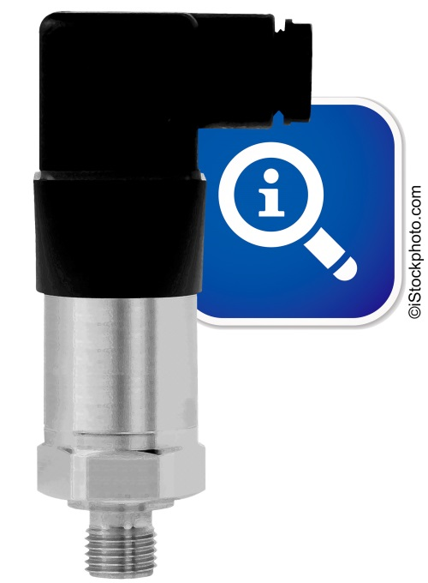

Edited by:
WIKA Instruments Ltd.
3103 Parsons Road
Edmonton, AB T6N 1C8 Canada
Tel. (+1) 780 463-7035
Fax (+1) 780 462-0017
E-mail marketing.ca@wika.com
www.wika.ca

WIKA press release 07/2014

