Portable calibrator measures pressures up to 10,000 bar

Klingenberg, June 2018.
With the CPH7000 portable process calibrator, high-pressure measuring instruments can now also be tested in the field: This multifunction instrument is the first hand-held from WIKA that records measured values of up to 10,000 bar.

For such measuring tasks, the portable calibrator uses the WIKA CPT7000 high-pressure sensor as an external reference. Its rupture-proof, thin-film cell is not welded. It is inserted tightly into a tapered pressure channel and is thus also insensitive to dynamic pressure profiles.

Through the combination with this sensor, the already broad range of applications for the CPH7000 is expanded even further. The calibrator is a portable multifunction instrument with an integrated electrical module, a hand pump to generate test pressures up to 25 bar and a high-performance data logger. In addition to the calibration of process transmitters and pressure gauges, the same instrument can fulfil test tasks for the measurands of temperature, voltage and current.

The safety-related quality of the CPH7000 is also accredited internationally through the CSA “Safety” approval.

Number of characters: 1100
Key word: CPH7000 high pressure

WIKA company photograph:
With the CPH7000 portable process calibrator, high-pressure measuring instruments can now also be tested in the field

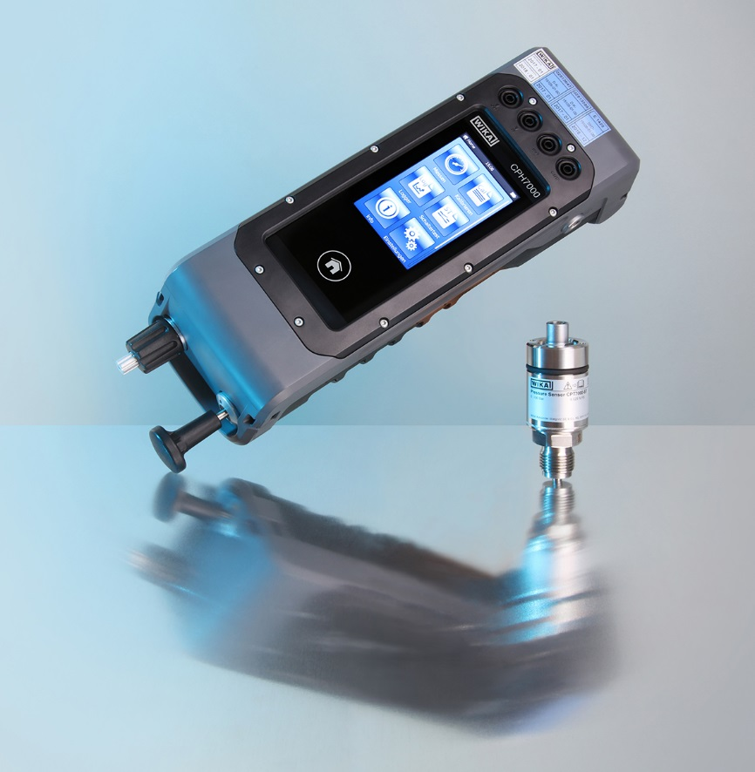

Edited by:
WIKA Instruments Ltd.
3103 Parsons Road
Edmonton, AB T6N 1C8 Canada
Tel. (+1) 780 463-7035
Fax (+1) 780 462-0017
E-mail marketing.ca@wika.com
www.wika.ca

WIKA press release 07/2018

