Brochure for the steel industry:
Measurement technology at a glance

Klingenberg, June 2019
For the iron and steel industry, WIKA has released a new brochure with its measurement technology for efficient process control. It provides a compact overview of industry-specific products and solutions for pressure, temperature, force, level and flow.

The comprehensive selection considers the sometimes extreme process conditions in this market segment, with pressures of up to 10,000 bar and temperatures of up to 2,000 °C. It is illustrated using a visualisation of an integrated steelworks: From the sinter plant, through the blast furnace to the continuous casting plant, each individual area is depicted with a corresponding range of relevant measuring instruments. In addition, customers receive information about engineered solutions and sensors for networked processes (keyword IIoT). A further chapter is devoted to calibration technology and its associated services.

The new brochure can be downloaded as a PDF file from the website www.wika.com or requested as a print version.

Number of characters: 989
Key words: Brochure for the iron and steel industry

WIKA company photograph:
Brochure for the steel industry: Measurement technology at a glance

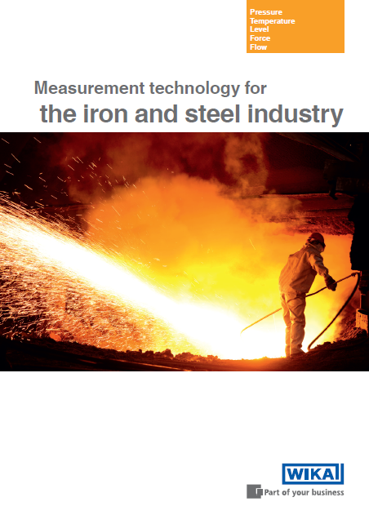

Edited by:
WIKA Instruments Canada Ltd.
3103 Parsons Road
Edmonton, AB T6N 1C8 Canada
Tel. (+1) 780 463-7035
Fax (+1) 780 462-0017
E-mail marketing@wika.ca
www.wika.ca

WIKA press release 07/2019

