A-10 pressure transmitter
now available with GL approval

Klingenberg, August 2014.
Another seal of approval for WIKA's A-10 pressure transmitter: Germanischer Lloyd has awarded the measuring instrument with
GL approval.

The certificate has been issued for “Environmental Category D, H, EMC1”. The now approved A-10 will be used primarily in conventional applications on-board ships (engines and automation technology). It is, however, also suitable for other offshore applications, such as in wind farms and on oil rigs.

The pressure transmitter has been designed for a wide spectrum of applications in industry. It can be delivered with all the standard process connections and output signals, as well as international approvals such as cULus and GOST-R.

Number of characters: 753
Key words: A-10 with GL

WIKA company photograph:
A-10 pressure transmitter with GL approval −
primarily for conventional applications on-board ships

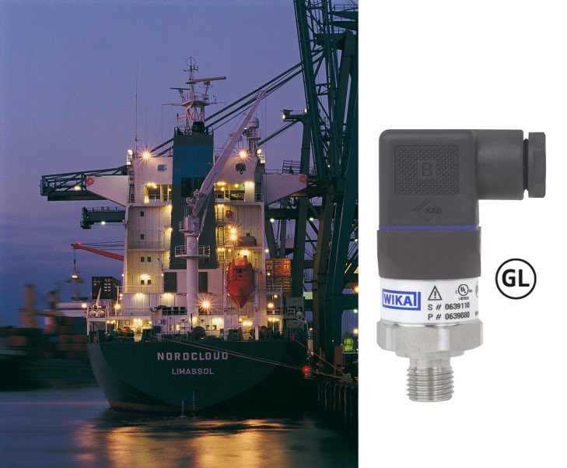

Edited by:
WIKA Instruments Ltd.
3103 Parsons Road
Edmonton, AB T6N 1C8 Canada
Tel. (+1) 780 463-7035
Fax (+1) 780 462-0017
E-mail marketing.ca@wika.com
www.wika.ca

WIKA press release 08/2014

