Miniature thermometer for sterile processes
gets Ex approvals

Klingenberg, March 2015.
The TR21 miniature resistance thermometer from WIKA is currently the only instrument on the market that combines a housing of only 19 mm diameter with explosion protection. The measuring instrument, developed for sanitary applications, has now obtained ATEX and IECEx approval for the ignition protection type Ex i.

The combination of compact size, hygienic design and intrinsic safety makes the TR21 a multi-application thermometer for processes in the food and pharmaceutical industries. It is impervious to environmental influences (IP 69K ingress protection) and also easily cleanable from outside and suited to wash-down processes.

The TR21 works in a measuring range from -50 … +250 °C. It is delivered with a direct sensor output (Pt100) or integrated transmitter (4 … 20 mA output). The integration into the process is achieved via a welded connection, orbital welding or a thermowell.

Number of characters: 893
Key words: TR21 with Ex approvals

WIKA company photograph:
WIKA resistance thermometer TR21 with explosion protection

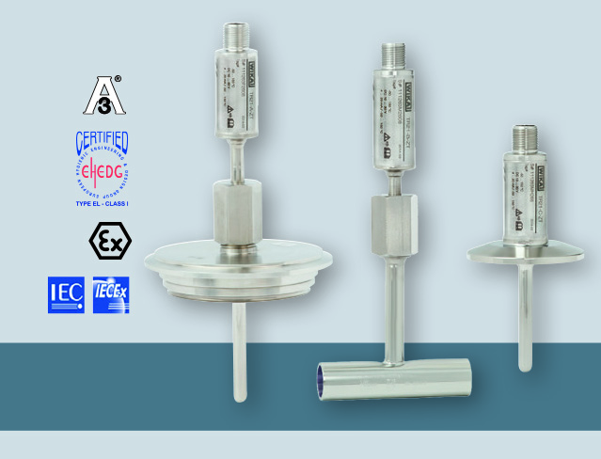

Edited by:
WIKA Instruments Ltd.
3103 Parsons Road
Edmonton, AB T6N 1C8 Canada
Tel. (+1) 780 463-7035
Fax (+1) 780 462-0017
E-mail marketing.ca@wika.com
www.wika.ca

WIKA press release 08/2015

