New OEM pressure sensor
for mobile working machines
Klingenberg, June 2020. Reliable and highly accurate: WIKA's new OEM pressure sensor for mobile working machines, the model MH-4, has been tailored to a wide spectrum of applications under extreme conditions.

The robustness of the new sensor has been confirmed through hardness tests in accordance with mobile hydraulic standards and on a customer-specific basis. The model MH-4 measures continuously with an accuracy of up to ≤ ±1.0 % FS. Tests on the electronics returned a load cycle stability of 100 million cycles and a long-term drift of ≤ ±0.1 % FS over the entire life cycle. The sensor withstands pressure spikes in hydraulic systems with up to three-times overload safety, vibrations up to 40 g and mechanical shocks of up to 100 g. Furthermore, it is insensitive to fast temperature changes between -40 °C and 125 °C as well as immune against electrical field strengths of up to 100 V/m.

The new OEM sensor can be customised and custom-labelled. The production of the model MH-4 ensures high quantities, even for individualised variants.

Number of characters: 1.022
Key word: MH-4

WIKA company photograph:
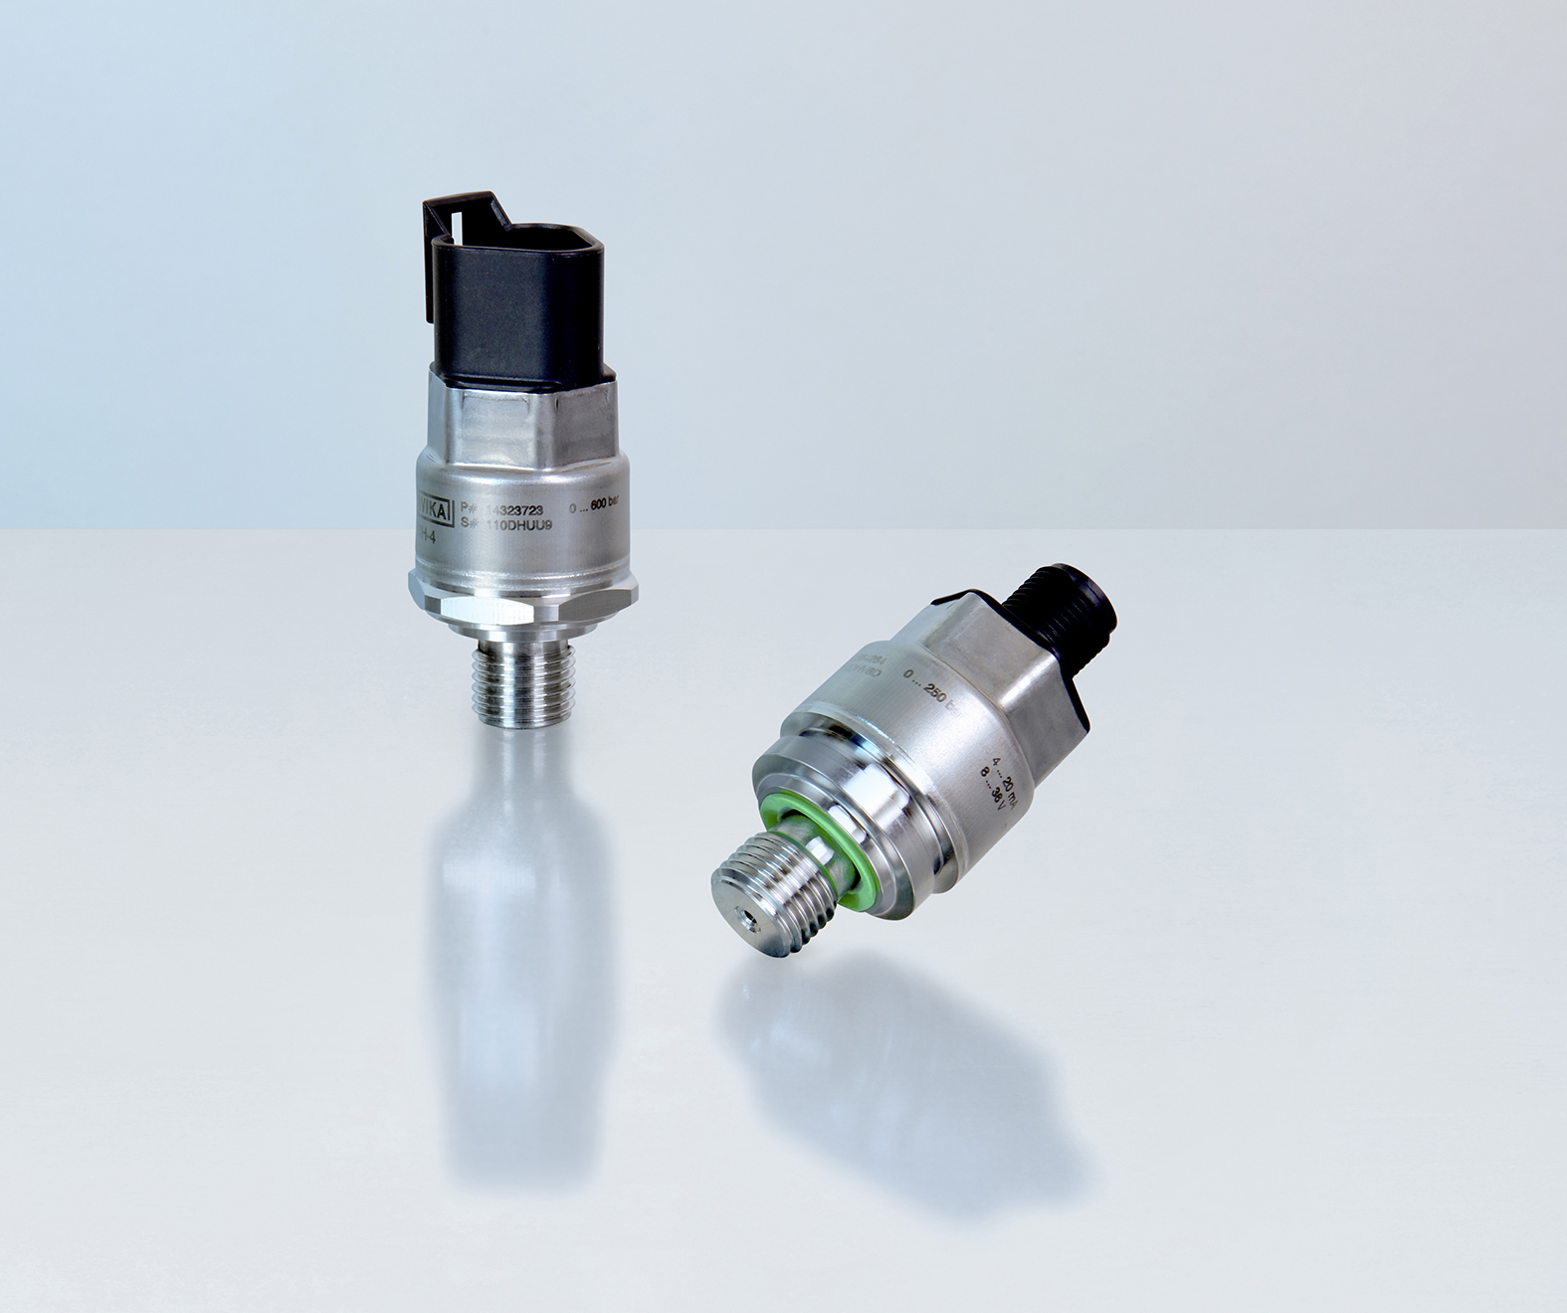
Typ: MH-4

Edited by:
WIKA Instruments Ltd.
3103 Parsons Road NW
Edmonton AB T6N 1C8 Canada
Tel. (+1) 780 463-7035
Fax (+1) 780 462-0017
E-mail: marketing.ca@wika.com
www.wika.ca

WIKA press release

