Pressure transmitter A-10
now also in block design

Klingenberg, March 2015.
The A-10 pressure transmitter is now also available in a block design. This particularly robust variant of the all-round instrument is especially suited to shipbuilding applications.

In the block design version, the A-10 is flanged, and not installed using the threads, as is usually done. There are two through-holes available for fastening. The pressure adaption is made either via a flange connection or a G 1/4 female thread.

Since last year, the A-10 has held a GL approval (Germanischer Lloyd) for use in offshore applications. This certificate is now also valid for the block design.

Number of characters: 588
Key words: A-10 in block design

WIKA company photographs:
Pressure transmitter A-10 in block design

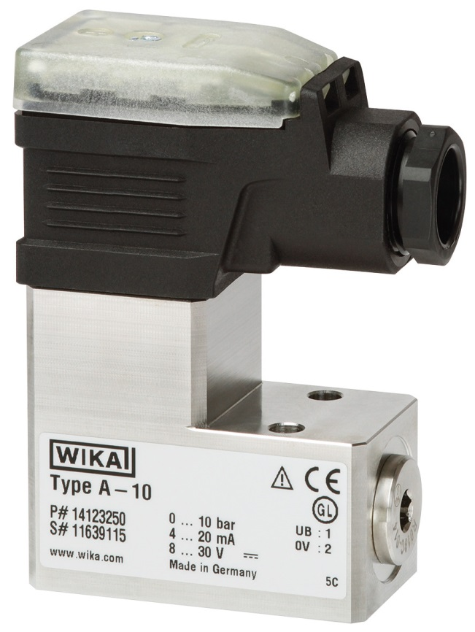

Edited by:
WIKA Instruments Ltd.
3103 Parsons Road
Edmonton, AB T6N 1C8 Canada
Tel. (+1) 780 463-7035
Fax (+1) 780 462-0017
E-mail marketing.ca@wika.com
www.wika.ca

WIKA press release 09/2015

