Thermowell wake frequency calculation
in accordance with the latest ASME standard

Klingenberg, May 2016.
WIKA has adapted its wake frequency calculation to the latest ASME standard, PTC 19.3 TW-2016. Customers can request version 2.6 of the calculation program via the www.wika.ca website.

ASME (American Society of Mechanical Engineers) has revised the content of its globally accepted standard for the calculation of thermowell wake frequencies and redesigned it for better readability. The new PTC 19.3 (performance test code) TW-2016 contains, among other things, changes to the dimensional limits of stems. Furthermore, in the revision the instructions for the mounting of thermowells in elbows and for inclined fitting in pipelines are more clearly defined, and also the rounding errors in the calculation examples are adjusted.

Number of characters: 728
Key words: ASME PTC 19.3 TW-2016

WIKA company photograph:
Graphic chart of thermowell calculation for temperature measuring points

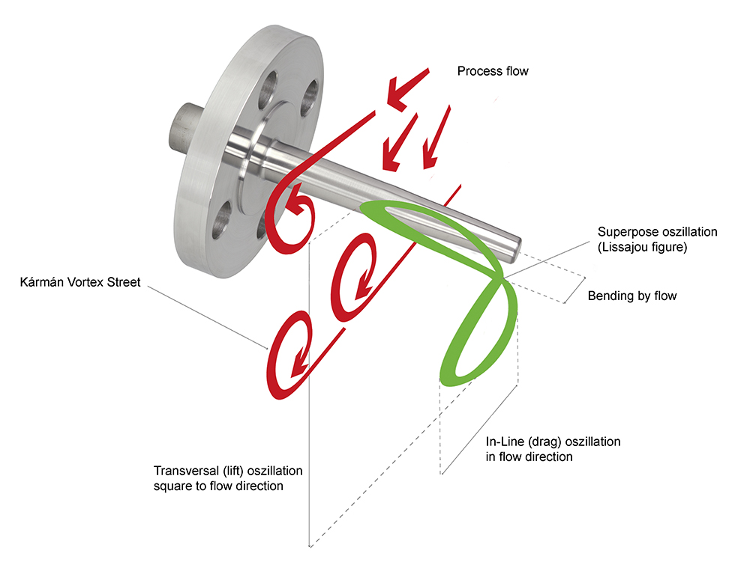

Edited by:
WIKA Instruments Ltd.
3103 Parsons Road
Edmonton, AB
T6N 1C8
Canada
Tel. (+1) 780 463-7035
Fax (+1) 780 462-0017
E-mail marketing.ca@wika.com
www.wika.ca

WIKA press release 09/2016

