New check valve
with redundant sealing
Klingenberg, August 2020. The new model CV check valve from WIKA is designed for a wide range of applications in the process industry. Its sealing system with a self-centering piston reliably prevents backflow of liquid and gaseous media.

The reliability of the new instrumentation valve is mainly due to its redundant sealing, consisting of an O-ring and a metal cone. Its leak tightness has been tested in accordance with BS6755/ISO 5208 leakage rate A. The solid-machined, robust design of the model CV ensures high repeatability and a long service life, even in heavy-duty applications. The pressurized parts correspond to the safety factor of 4:1.

For the new check valve, WIKA offers an application-specific assembly with a measuring instrument. Such an instrument hook-up is delivered ready-to-install and leak tested.

Number of characters: 797
Key word: CV

WIKA company photograph:
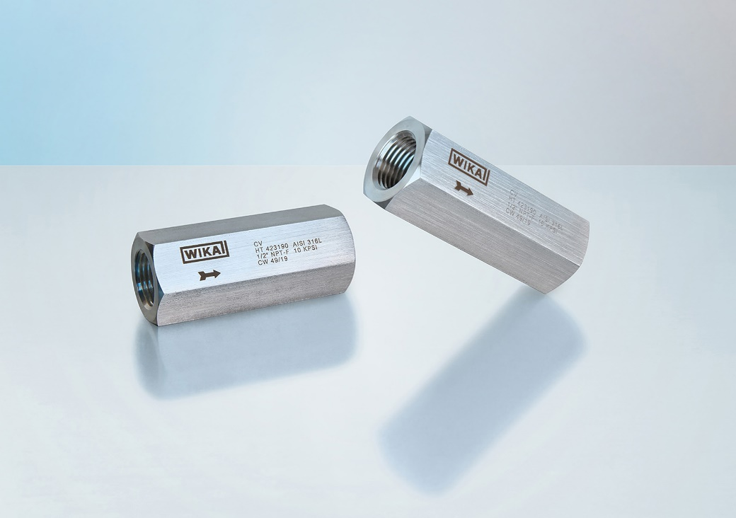
Typ: CV

Edited by:
WIKA Instruments Ltd.
3103 Parsons Road NW
Edmonton, AB T6N 1C8 Canada
Tel. (+1) 780 463-7035
Fax (+1) 780 462-0017
E-mail: marketing.ca@wika.com
www.wika.ca

WIKA press release

