New thermowell design prevents vibration

Edmonton, April 2015.
For applications in processes with high flow rates, WIKA is now offering thermowells in the new ScrutonWell® design. This variant is damping the excitation that leads to vibrations, which in turn can cause failures.

The ScrutonWell® design is applicable to all solid-machined, barstock thermowells from WIKA. The helical form of the stem is available in two versions: manufactured in a single piece or with helices welded onto it. Installation and removal are just as easy as with a standard thermowell.

ScrutonWell® thermowells are recommended when a thermowell fails the strength calculation, according to ASME PTC 19.3 TW-2010, and where other optimisations (shorter or stronger stem or support collar) are not desirable. In comparison with the conventional stem form, the new design reduces the excitations causing vibration by more than
90 %.

Number of characters: 845
Key words: Thermowells in ScrutonWell® design

WIKA company photograph:
WIKA thermowell in ScrutonWell® design

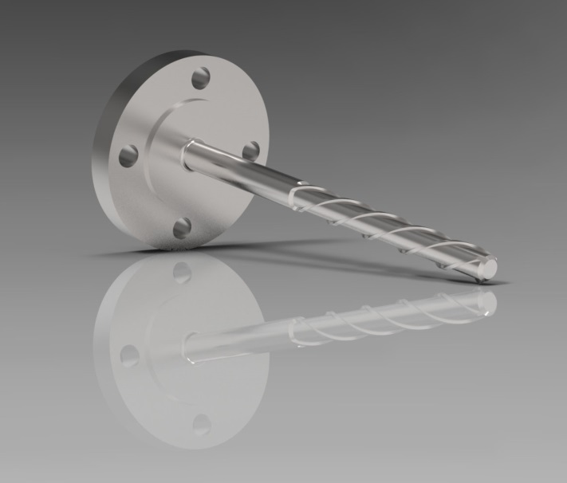

Edited by:
WIKA Instruments Ltd.
3103 Parsons Road
Edmonton, AB T6N 1C8 Canada
Tel. (+1) 780 463-7035
Fax (+1) 780 462-0017
E-mail marketing.ca@wika.com
www.wika.ca

WIKA press release 11/2015

