Compact instrumentation valve:
Monoblock with ball valves

Klingenberg, December 2019. WIKA's new model IBF monoblock with flange enables the safe connection of pressure measuring instruments to critical processes, for example with natural gas or aggressive, highly viscous and crystalline media. It is available with ball valves and needle valves in double block & bleed or block & bleed configurations.

The compact design of the new instrumentation valve reduces the dimensions, vibration sensitivity and leakage potential of the complete measuring assembly. The 10 mm bore of the ball valves ensures a smooth medium flow. A combination of plastic and metal sealing assists safe operation: In the event of failure of the “soft” seal, the pressure presses the ball seamlessly into its metal seat. The leak tightness of the redundant system has been tested in accordance with BS6755 / ISO 5208 leakage rate A. The manufactured quality of the valve ensures smooth handling with low torque, even at high process pressures.

WIKA offers users a customer-specific assembly of monoblock and measuring instrument. Such a “hook-up” is delivered ready-to-use and leak tested.

Number of characters: 1079
Key word: Monoblock IBF

WIKA company photograph:
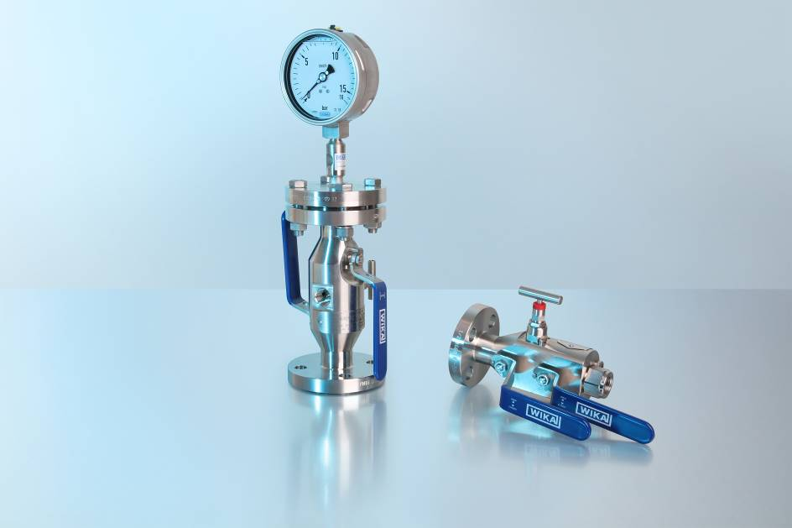
Caption: IBF group picture

Edited by:
WIKA Instruments Canada Ltd.
3103 Parsons Road
Edmonton, AB T6N 1C8
Canada
Tel. (+1) 780 463-7035
Fax (+1) 780 462-0017
E-mail: marketing.ca@wika.com
www.wika.ca

WIKA press release

