Float switches: New options
allow a more compact design
Klingenberg, August 2020. Machines are becoming more and more compact. Therefore, WIKA's RLS-1000 and RLS-2000 float switches, designed for industrial applications, are now also available with smaller process connections from G1/2 and floats with diameters starting from 18 mm.

Both instruments ensure reliable level monitoring in narrow installation spaces and great flexibility of use. Even with small sizes, up to four switch points (reed contacts) can be set individually. The compact measuring instruments are supplied ready for operation and are easy to install. Customer-specific solutions can be implemented even for small purchase quantities.

Thanks to their robust design, the two float switches require little maintenance. The RLS-2000 model is designed for applications with corrosive media. Its wetted parts are optionally made of PP, PVDF and now also of PVC.

Number of characters: 848
Key word: RLS-1000/-2000

WIKA company photograph:
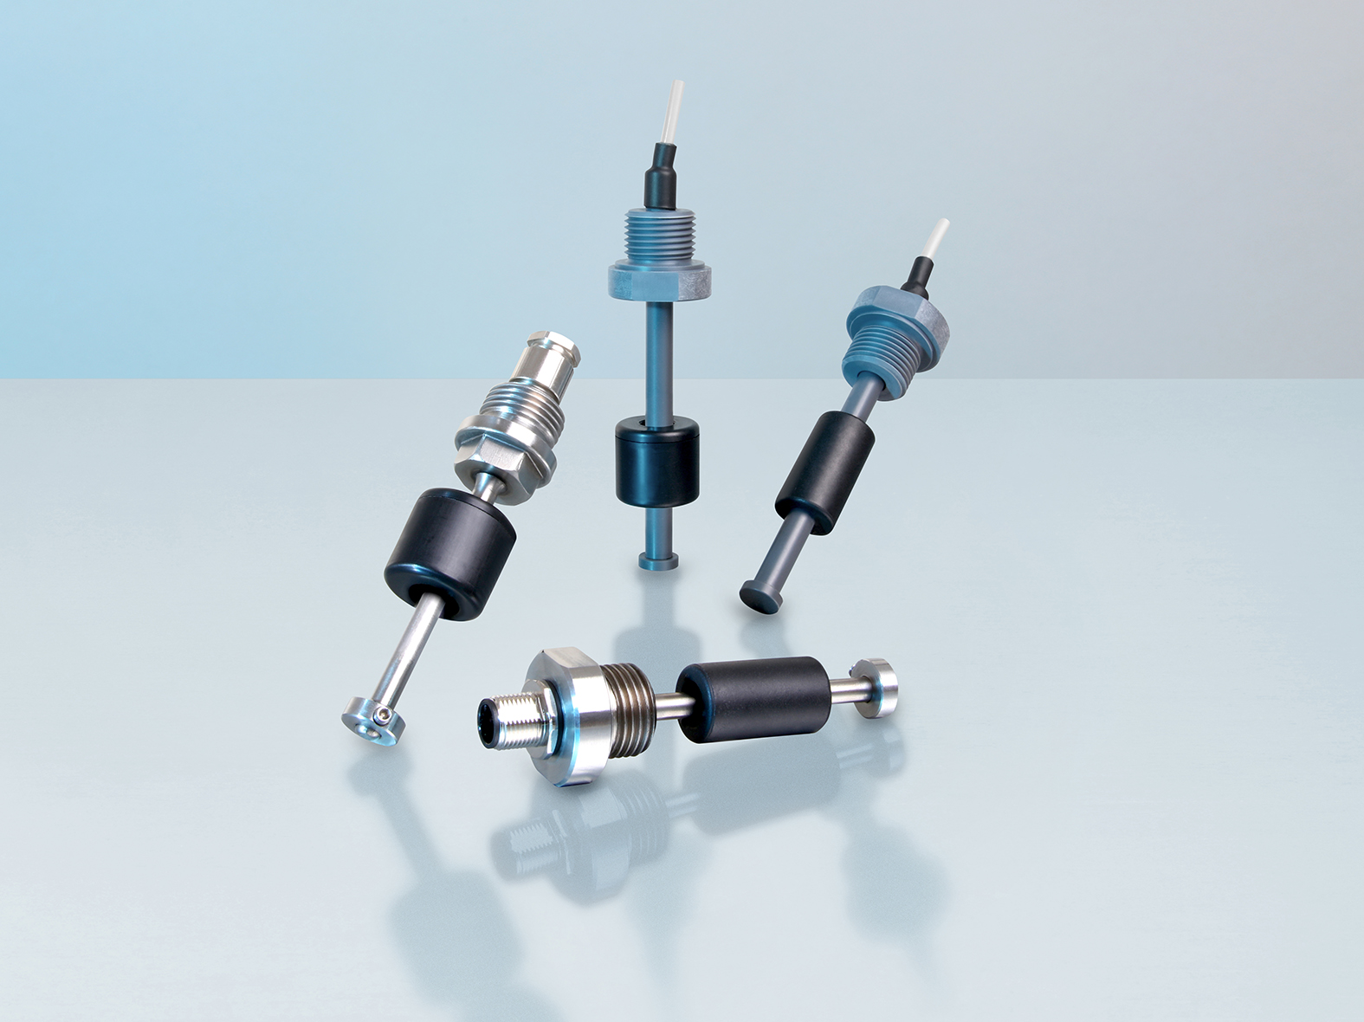
Model RLS-1000 and RLS-2000

Edited by:
WIKA Instruments Ltd.
3103 Parsons Road NW
Edmonton, AB T6N 1C8 Canada
Tel. (+1) 780 463-7035
Fax (+1) 780 462-0017
E-mail: marketing.ca@wika.com
www.wika.ca

WIKA press release

