New WIKA Canada Website: More information with fewer clicks

press release

Edmonton, June 2015.
With a fresh design, efficient navigation and additional functionality, WIKA's new website offers visitors more with fewer clicks.

The new website is much tidier, visually clearer and has a wider range of services to offer. Customers can, for example, find the instrument they are looking for via a new product selector or directly using mega menus. Cross references will let them know about accessories, related products or applicable trade articles and WIKA blogs. By using a search form on the same level, the appropriate sales contacts, in the field or in the office, can be identified.
A mega menu dedicated to WIKA Canada’s distribution partners provides additional information on the extensive product lines that WIKA Canada represents.
Furthermore, the newly designed Internet presence offers an expanded FAQ section, an extensive list of application notes and a detailed career area with an international appointments section. The website is linked with social media, including the WIKA channel on YouTube. On top of this, it is optimized for search engines and tablet PCs.

Number of characters: 1,156
Key words: New website

Manufacturer:
WIKA Instruments Canada Ltd.
3103 Parsons Road
Edmonton, AB
T6N 1C8
Canada
Tel. (+1) 780 463-7035
Fax (+1) 780 462-0017
E-mail info@wika.ca

www.wika.ca

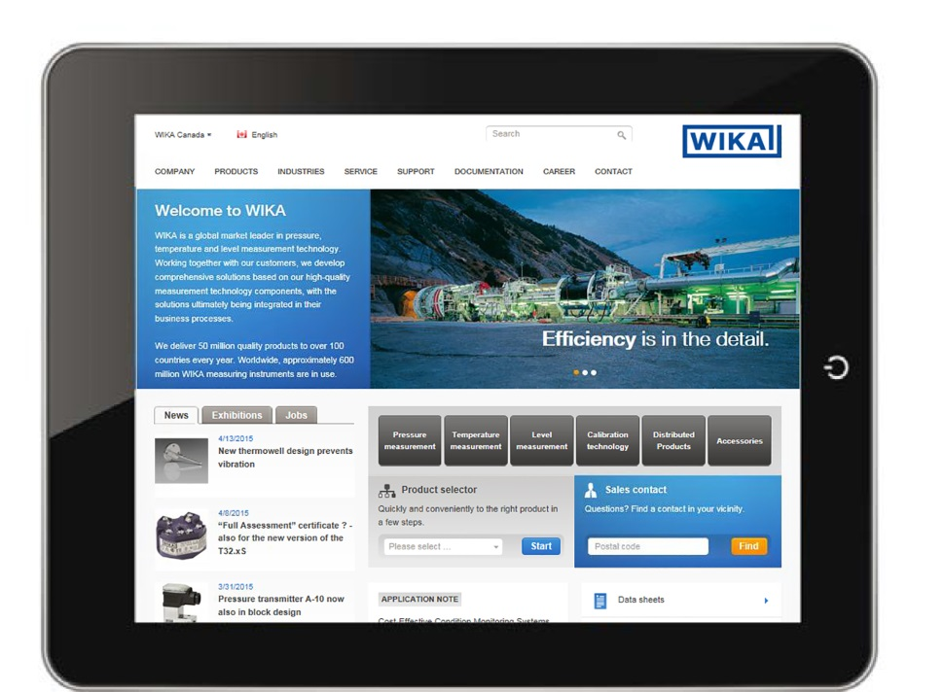

Edited by:
WIKA Instruments Canada Ltd.
3103 Parsons Road
Edmonton, AB
T6N 1C8
Canada
Tel. (+1) 780 463-7035
Fax (+1) 780 462-0017
E-mail marketing@wika.ca

www.wika.ca

