Portable pressure calibrator
with electric pressure pump

Klingenberg, November 2018.
WIKA has expanded its range of portable calibrators to include an instrument with integrated electric pressure pump. Besides, the new model CPH7650 pressure calibrator - designed within a robust case - is multi-functional: It also fulfils test tasks for the measurement parameters of voltage and current.

As a reference, the CPH7650 uses the proven model CPT6000 sensor with an accuracy of 0.025 % FS. The sensor is exchangeable, which increases the versatility of the instrument and optimises recalibration. With the electric pump, users can generate a test pressure of -0.85 bar ... +20 bar on site, and control it precisely at the touch of a button. The pump power is continuously adjustable.

Like the CPH7000 hand-held model (with mechanical pressure pump), the CPH7650 has an electrical module for measuring voltage (DC 0 ... 30 V) and current (4 ... 20 mA) as well as supplying power to test items. All pressure and electrical values are simultaneously shown in the display and read via a USB interface.

Number of characters: 1008
Key words: Portable pressure calibrator CPH7650

WIKA company photograph
Portable pressure calibrator with electric pressure pump

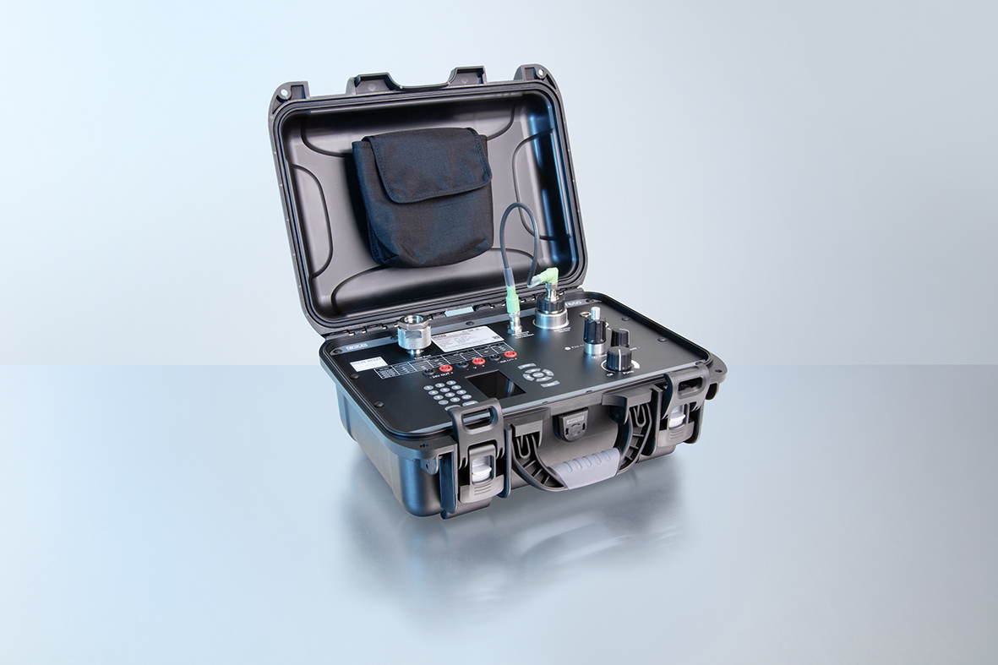

Edited by:
WIKA Instruments Canada Ltd.
3103 Parsons Road
Edmonton, AB T6N 1C8 Canada
Tel. (+1) 780 463-7035
Fax (+1) 780 462-0017
E-mail marketing.ca@wika.com
www.wika.ca

WIKA press release 12/2018

