Reed level transmitter
suitable for food applications
Klingenberg, October 2020. WIKA has expanded its range of level transmitters with reed measuring chain by adding the model FLR-F for food applications. The instrument has an electropolished surface with a roughness of < 0.8 µm Ra and is available with application-specific process connections such as TriClamp.

The level transmitter works on the float principle with magnetic transmission. It measures the level reliably, even with foaming, and can additionally output a temperature value. The reed contacts in the guide tube (up to six meters long) can be arranged as a quasi-continuous level measurement.

The model FLR-F is also available in a version with a head-mounted transmitter for different output signals and communication protocols. Furthermore, the instrument can be supplied with a removable float limitation and FDA-compliant sealing or in an ATEX variant for applications in which pipes are cleaned with flammable media.

Number of characters: 906
Key word: FLR-F

WIKA company photograph:
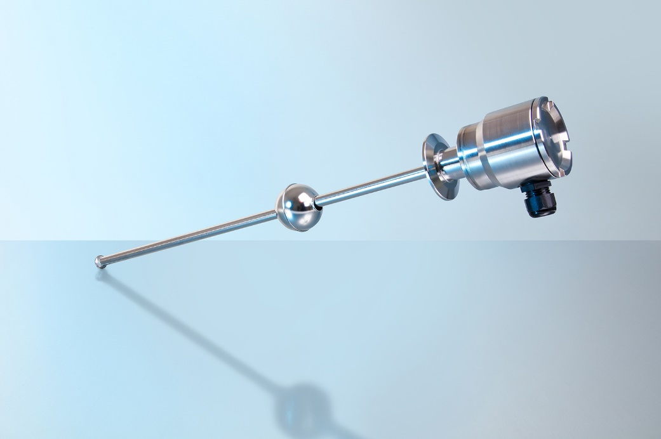
Typ: FLR-F

Edited by:
WIKA Instruments Ltd.
3103 Parsons Road NW
Edmonton, AB T6N 1C8 Canada
Tel. (+1) 780 463-7035
Fax (+1) 780 462-0017
E-mail: marketing.ca@wika.com
www.wika.ca

WIKA press release

