Miniature thermometer
now autoclavable

Klingenberg, June 2015.
New application possibility for the TR21 miniature resistance thermometer from WIKA: It is now also available in an autoclavable design.

The basic requirement for the use of the TR21 in sterilization processes under saturated steam is its consistent sealing concept (IP 69K ingress protection). The new instrument option adds to this feature with an electrical system from high-quality components which are matched to the high temperatures in autoclaves (134 °C, 273 °F). The hygienic thermometer operates with a direct sensor output (Pt100) or integrated transmitter (4 … 20 mA output) in a range of
-50 … +250 °C (-58 … +482 °F).

With a case diameter of only 19 mm (3/4”), the TR21 can also be integrated into the smallest units. The thermometer is currently the only instrument of its size to offer explosion protection. It is certified as intrinsically safe in accordance with ATEX and IECEx.

Number of characters: 887
Key words: TR21 for autoclaves

WIKA company photograph:
WIKA miniature thermometer TR21, now autoclavable

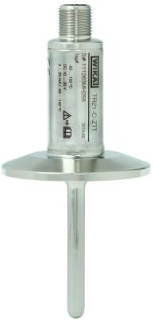

Edited by:
WIKA Instruments Ltd.
3103 Parsons Road
Edmonton, AB T6N 1C8 Canada
Tel. (+1) 780 463-7035
Fax (+1) 780 462-0017
E-mail marketing.ca@wika.com
www.wika.ca

WIKA press release 13/2015

