New PSD-4 pressure switch:
Freely configurable and scalable outputs
Klingenberg, September 2017.
More functionality in a proven design: With their new model PSD-4 electronic pressure switch, WIKA offers an extensive solution for automated applications, especially in machine building.

The further development of the successful PSD-30 model enables exceptionally flexible applications: The output signals (PNP/NPN, 4 … 20 mA or 0 … 10 V) are freely configurable. The output signal, with a turndown of 5:1, can be scaled to the relevant measuring range. Thus, with just one instrument variant, many specifications can be realized. This also minimizes the stockholding for distributors and users.

The PSD-4 features a nine millimeter high LED display with 14 segments, which can be rotated continuously through 330°. This enables measured value and status to be read optimally in any mounting situation. In addition, extensive diagnostic functions inform the user about the instrument status.

The new pressure switch is also available in a version with an IO-Link interface. Via this communications standard, it can be easily parameterized and integrated into existing systems. Worldwide usage of the PSD-4 is enabled through UL and EAC approvals.

Number of characters: 1146
Key word: PSD-4

WIKA company photograph:
Electronic pressure switch PSD-4

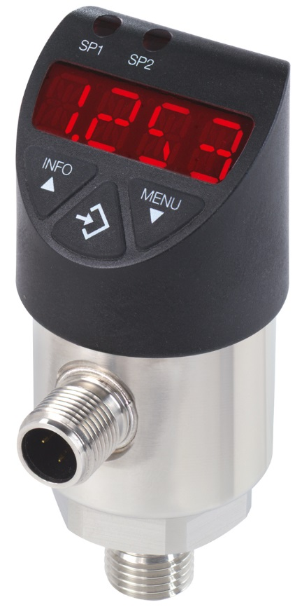

Edited by:
WIKA Instruments Ltd.
3103 Parsons Road
Edmonton, AB T6N 1C8
Canada
Tel. (+1) 780 463-7035
Fax (+1) 780 462-0017
E-mail marketing.ca@wika.com
www.wika.ca

WIKA press release 13/2017

