Robust needle valve
for high-pressure applications
Klingenberg, November 2020. WIKA has supplemented its portfolio of shut-off valves with the model HPNV high-pressure needle valve.

The new valve is designed for four pressure ranges: up to 15,000 psi (1,034 bar), up to 20,000 psi (1,379 bar), up to 30,000 psi (2,068 bar) and up to 60,000 psi (4,136 bar). The sensitive components - spindle tip and sealing - are made of suitably resistant material. Furthermore, the model HPNV has the same characteristics as the other WIKA needle valves: low-wear operation due to the non-rotating spindle tip, smooth handling with low torque and leak tightness tested to BS6755/ISO 5208 leakage rate A.

The high-pressure valve is available in various configurations and materials. WIKA also offers a customer-specific assembly of valve and measuring instrument. Such an instument hook-up is delivered ready-to-install and leak tested.

Number of characters: 840
Key word: HPNV

WIKA company photograph:
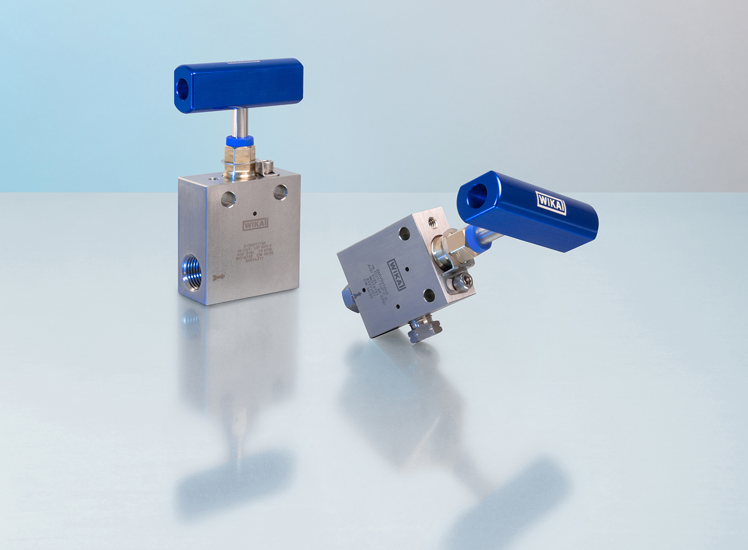
Typ: HPNV

Edited by:
WIKA Instruments Ltd.
3103 Parsons Road NW
Edmonton, AB T6N 1C8 Canada
Tel. (+1) 780 463-7035
Fax (+1) 780 462-0017
E-mail: marketing.ca@wika.com
www.wika.ca

WIKA press release

