WIKA Certified by ASME and NBIC

press release

Edmonton, November, 2013
WIKA Instruments Canada Ltd. certified to fabricate, repair and make alterations to components for pressure vessels

WIKA Instruments Ltd. is proud to announce we are certified to fabricate, repair and make alterations to components for pressure vessels in accordance to the American Society of Mechanical Engineers (ASME) and the National Board Inspection Code (NBIC). This certification allows WIKA Instruments Ltd. to use the ASME ‘U’ designator (for new construction) and NBIC ‘R’ designator (for repairs and alterations) for pressure vessel components as they relate to our product line.

Having the ASME ‘U’ and the NBIC ‘R’ certification along with the recent acquisition of Gayesco, allows WIKA to continue to grow as the market leader in the petrochemical, refining and process industries.

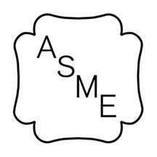 | 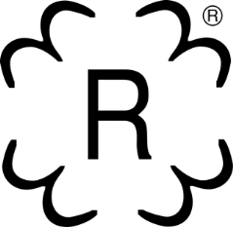
ASME ‘U’ Stamp  for new pressure vessel  component fabrication | NBIC ‘R’ Stamp  for repairs to pressure vessel  components

Edited by:
WIKA Instruments Canada Ltd.
Lloyd Clarke
Marketing Manager
2679 Bristol Circle, Unit 1
Oakville, ON L6H 6Z8
Tel: 905.337.1611
Fax: 905.337.2716
E-mail: l.clarke@wika.ca
www.wika.ca

