New pressure transducer − TI-1 with
signal processing for OEM customers

Klingenberg, July 2015.
WIKA has added a new OEM pressure transducer to its portfolio: Model TI-1 with digital signal processing is a fast and precise measuring device, e.g. for data loggers, process transmitters and hand-helds.

The TI-1 offers an adjusted sensor signal, for which no additional compensation is required. This enables a very customer-friendly integration of the pressure transducer into the respective application.

The TI-1 measures in ranges from 0 ... 0.4 bar to 0 ... 1,000 bar with an overall accuracy of up to 0.25 % of span and a non-linearity of max. 0.125 % of span (BFSL). The digital signals UART, I²C and SPI are available; on request, an analogue or switching signal is also possible. In addition, the digital interface of the TI-1 provides information on the sensor temperature, which, due to its design, is close to the actual process temperature.

Number of characters: 852
Key word: TI-1

WIKA company photograph:
WIKA OEM pressure transducer TI-1 with digital signal processing

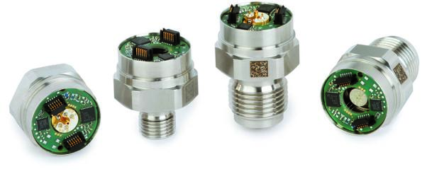

Edited by:
WIKA Instruments Ltd.
3103 Parsons Road
Edmonton, AB T6N 1C8 Canada
Tel. (+1) 780 463-7035
Fax (+1) 780 462-0017
E-mail marketing.ca@wika.com
www.wika.ca

WIKA press release 19/2015

